IMPEDANCE MATCH DOCUMENTATION

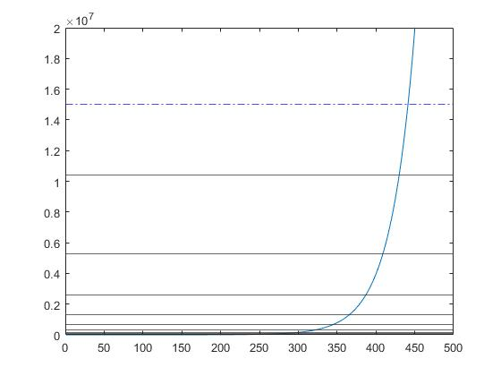
octave
19.7055780
2

40.1057288
3

79.0306568
4

160.8469483
5

316.9582089
6

645.0884089
7

1271.1839969
8
161590.8753896
15

2587.1740786
9

5098.1760644
10

10376.0501977
11

20446.6066658
12

41613.9055332
13

82002.6061993
14

328877.4285826
16

648071.9826312
17

1318986.8961987
18

2599139.9183829
19

5289893.0760982
20

10424040.0702156
21

21215501.7136245
22

numfreq = 500;
y = logspace(1,8,numfreq);
stopFreq = y(numfreq);
startFreq = y(1);
a = double(startFreq);
c = 1;
figure(4);
plot(y);
xlim([0 numfreq]);
ylim([0 20000000]);
yline(15*10^6,'-.b');

while a <= 15000000

a = a*2;
[val,idx]=min(abs(y-a));
minVal=y(idx);

fprintf('%.7f\n',minVal)

yline(minVal);

c = c+1;
disp(c);

end

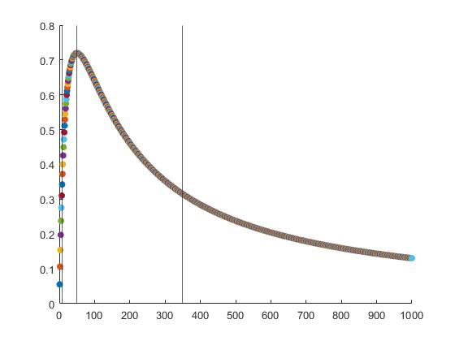
Vs = 12;
Zs = 50;
Zl = 0;
PL = 0;
figure(2);
scatter(Zl,PL,'filled');
x = [];
for c = 1:1000
Zl = Zl+1;
PL = (((Vs)/(Zs+Zl))^2)*Zl;
disp(PL);
scatter(Zl,PL,'filled');
hold on
x = [x, PL];
end
xline(50);
xline(7);
xline(350);
[M,I] = max(x)

Calculations

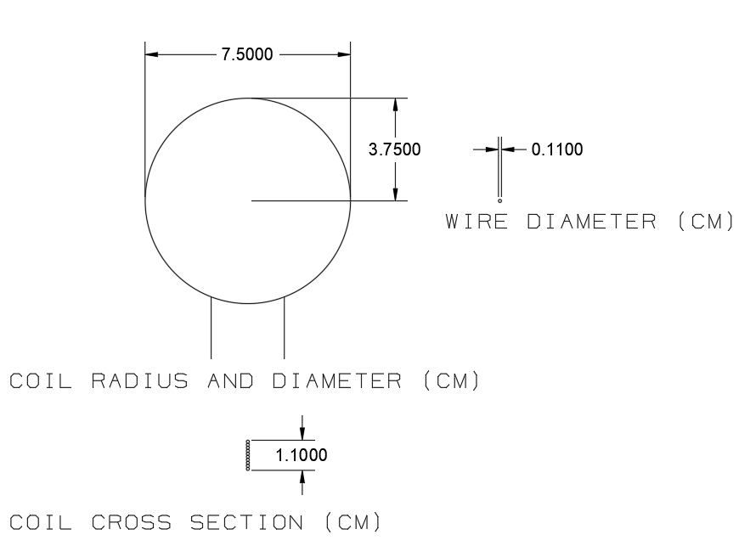
Final Coil Inductance: 50.469 uH

Transformer 1
Boundaries: ~%43.75 –--- %100 –--- ~%43.75
Primary Impedance: 7Ω 50Ω 350Ω
Transformer 1 Frequency Range: 160.84Hz 1277.17Hz 5.098Khz

Inductor Impedance Formula: Xl = 2ΠfL
f = frequency
L = Coil Inductance

Coil Impedance at 160.84 Hz: 2Π(160.84)(50.469*10^-6) = .05097748Ω

Impedance Matching Formula: (Primary Turns/Secondary Turns) = sqrt(Primary Impedance/Secondary Impednace)

(100/Secondary Turns) = sqrt( 7Ω / .05097748Ω )
Secondary Turns: 9
Final Turn Ratio 100:9
(100/90) = sqrt( 50Ω / Secondary Impedance)
Secondary Impedance: 2.853
Coil Frequency at Specific Impedance: 0.405 = 2Πf(50.469*10^-6)
Coil Frequency at Specific Impedance: 1277.17Hz

(100/90) = sqrt( 350Ω / Secondary Impedance)
Secondary Impedance: 2.835
Coil Frequency at Specific Impedance: Ω2.835 = 2Πf(50.469*10^-6)
Coil Frequency at Specific Impedance: 8.94 Khz

Normalized based on octave allocations: 5.098 Khz
Secondary Impedance at 5.098 Khz: 1.61578Ω
Primary Impedance at 5.098Khz: Ω199.469
Power Transfer at Primary Impedance: 64%

Transformer 2
Boundaries: ~%43.75 –--- %100 –--- ~%43.75
Primary Impedance: 7Ω 50Ω 350Ω
Transformer 1 Frequency Range: 5.098Khz 36.32Khz 328.7Khz

Inductor Impedance Formula: Xl = 2ΠfL
f = frequency
L = Coil Inductance

Coil Impedance at 5.098Khz Hz: 2Π(5098)(50.469*10^-6) = 1.61578Ω
Impedance Matching Formula: (Primary Turns/Secondary Turns) = sqrt(Primary Impedance/Secondary Impednace)

(100/Secondary Turns) = sqrt( 7Ω / 1.61578Ω )
Secondary Turns: 48
Final Turn Ratio 100:48

(100/90) = sqrt( 50Ω / Secondary Impedance)
Secondary Impedance: 11.52Ω
Coil Frequency at Specific Impedance: 11.52Ω = 2Πf(50.469*10^-6)
Coil Frequency at Specific Impedance: 36.3215 Khz

(100/90) = sqrt( 350Ω / Secondary Impedance)
Secondary Impedance: 80.64Ω
Coil Frequency at Specific Impedance: 80.64Ω = 2Πf(50.469*10^-6)
Coil Frequency at Specific Impedance: 254.299824 Khz

Normalized based on octave allocations: 328.7Khz
Secondary Impedance at 328.7 Khz: 104.17Ω
Primary Impedance at 5.098Khz: 452.126Ω
Power Transfer at Primary Impedance: 35.27%

Transformer 3
Boundaries: ~%43.75 –--- %100 –--- ~%43.75
Primary Impedance: 7Ω 50Ω 350Ω
Transformer 1 Frequency Range: 328.7Khz 2.397Mhz 21.215Mhz

Inductor Impedance Formula: Xl = 2ΠfL
f = frequency
L = Coil Inductance

Coil Impedance at 328.7 Khz: 2Π(328.7Khz)(50.469*10^-6) = 104.17Ω
Impedance Matching Formula: (Primary Turns/Secondary Turns) = sqrt(Primary Impedance/Secondary Impedance)

(100/Secondary Turns) = sqrt( 7Ω / 104.17Ω )
Secondary Turns: 48
Final Turn Ratio 10:39

(100/90) = sqrt( 50Ω / Secondary Impedance)
Secondary Impedance:760.5Ω
Coil Frequency at Specific Impedance: 760.5Ω = 2Πf(50.469*10^-6)
Coil Frequency at Specific Impedance: 2.398 Mhz

Coil Impedance for a Frequency of 21.215Mhz: 6723.9Ω = 2Π(2398251)(50.469*10^-6)
Primary Impedance: 442.07
Power Delivery at this Impedance: %36.51

Header J1

Header J2

Relay Driver Sim

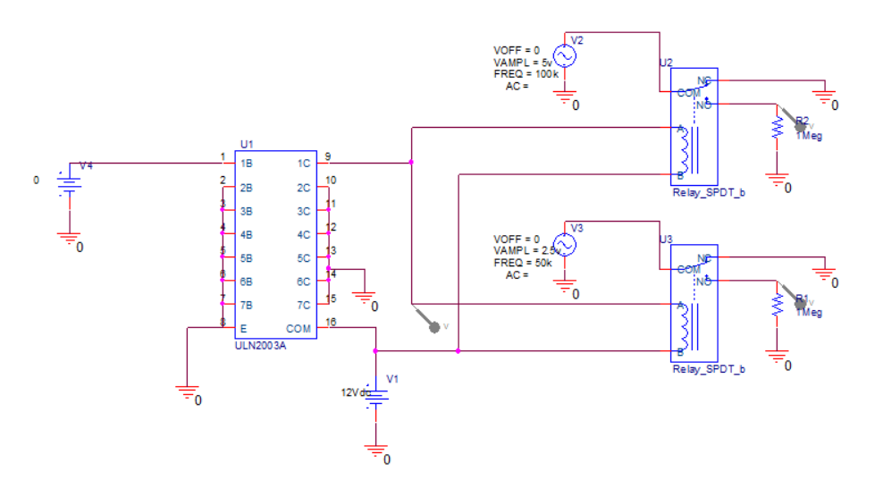
The relay circuit was simulated to ensure that driver IC could drive 2 relays per channel. Relay J2 was fed by a 100KHz sin source, relay J3 was fed by a 50KHz sin source. When the voltage to pin 1B is 0 the output should be 0, when voltage to pin 1B is 3.3v the output of each relay should be a sin waves with an amplitude of 5v and 2.5v respectively and a frequency of 100Khz and 50KHz respectively.
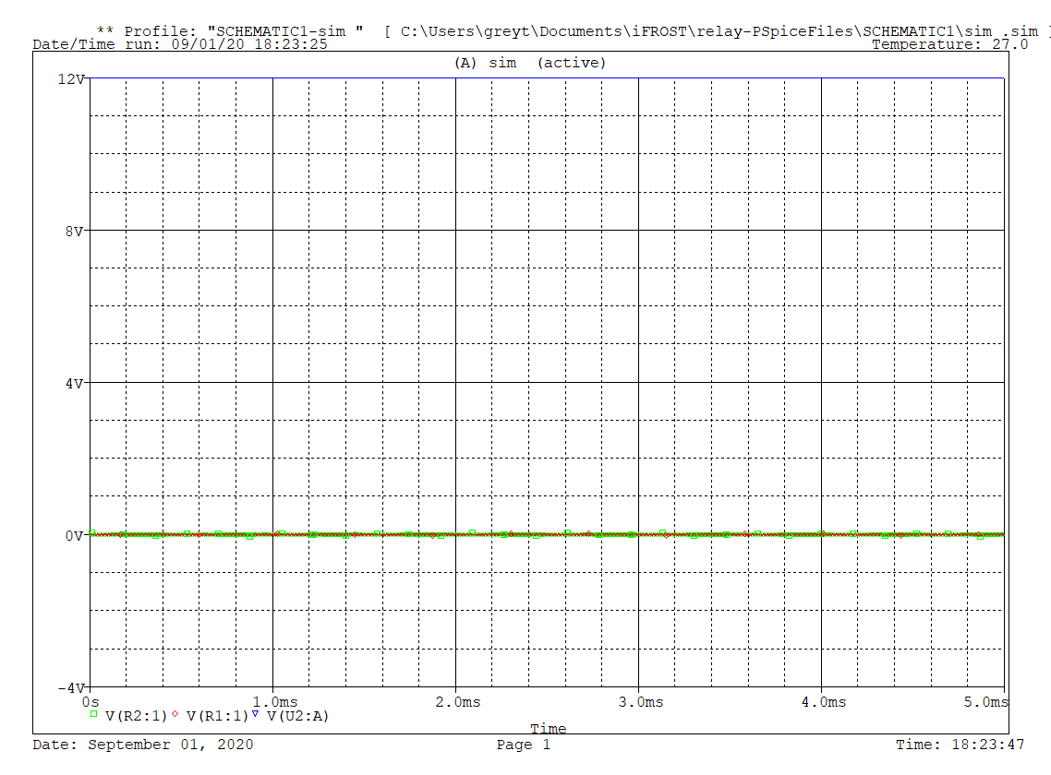

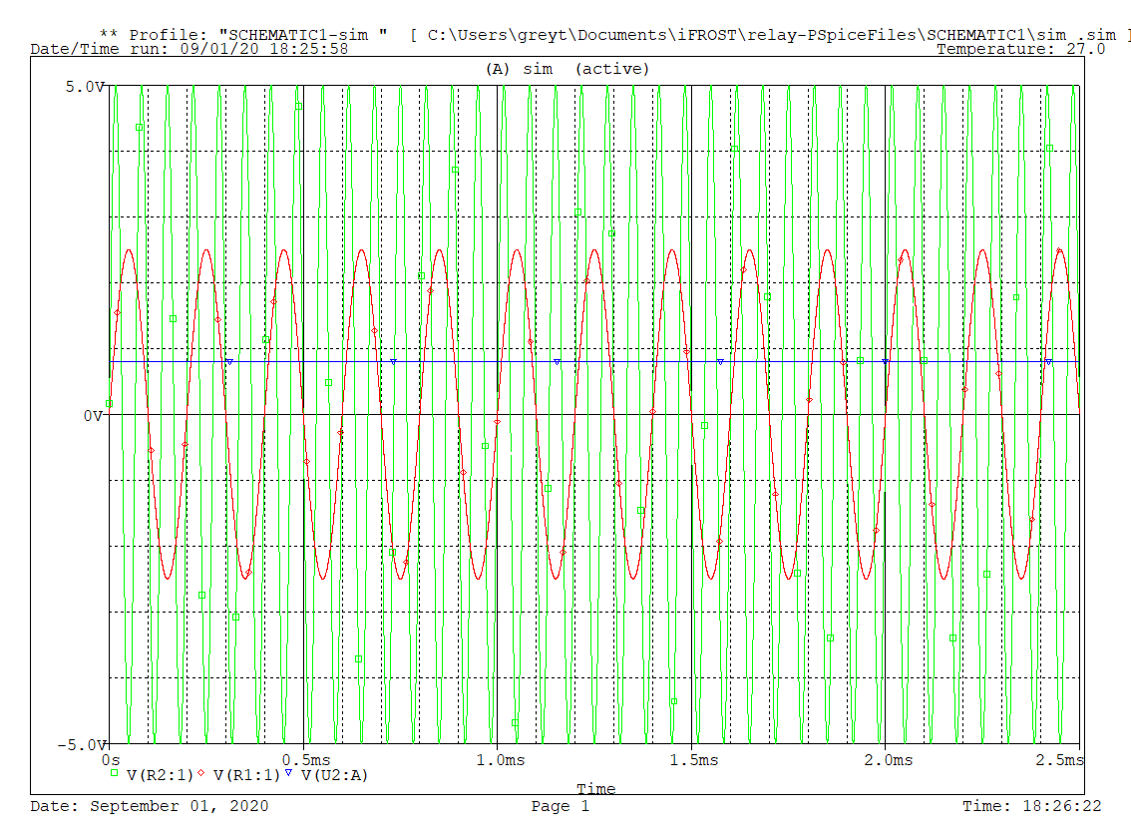
Red Trace: J3 output
Green Trace: J2 output
Blue Trace: Relay driver common

